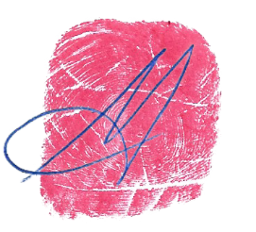

STAND DOWN ORDER

Issued by the [NAME] Common Law Assembly (XXCLA)
A lawful de jure Government and Court established by the People of the [REGION NAME]

BE ADVISED that you are in violation of the XXCLA Public Safety Bylaw No. [NUMBER] issued by We the People in Lawful Assembly on [DATE]: “Abolishing and Outlawing COVID Restrictions, Mandatory Vaccinations and other Unlawful, Unhealthy and Unwarranted Measures in our Community”.

YOU ARE HEREBY ORDERED to immediately cease and desist from requiring or imposing any COVID regulations on anyone in our community, including masking, social distancing, quarantines, mandatory vaccinations, or other unwarranted, unhealthy, and unlawful measures.

Failure to comply will result in a 350 troy ounces of silver penalty fine per incident, per owner and/or each director on conviction by the Common Law Court of the [REGION], [STATE], Australia

This STAND DOWN ORDER has the full effect and force of the Law and will be enforced by the Sheriff’s

Department of the XXXXXX Common Law Assembly and its sworn deputies.

Issued on [DATE] in the [REGION] and duly registered in the Public Records Office of the Assembly.

Authorized by the [NAME] Common Law Assemblies

Michael Thomas Holt
Common Law Sheriff

